Blue Carbon Lab
Air pump user manual



1. Set up guide ………………………………….………………….…… 3

1.1. Download required software …………………………….…… 3
1.2. How to set the time for the pumps …………………………… 4
1.2.1. Modify the script ………………………….………….. 4
1.2.2. Uploading script to the pump ………………………….7

2. Batteries replacement & notice …………………………………… 11

3. Trouble shooting …………………………………………………….12

1. Set up guide

1.1. Download required software
- In order to set the new time for the pumps or to track it status, an Arduino IDE application need to be downloaded on your local computer, please click on your options

- Windows
- MacOS (Mojave or newer)
- MacOS (Big Sur or newer)
- Linux

- Note: If you’re taken to this page, please click “Just download”
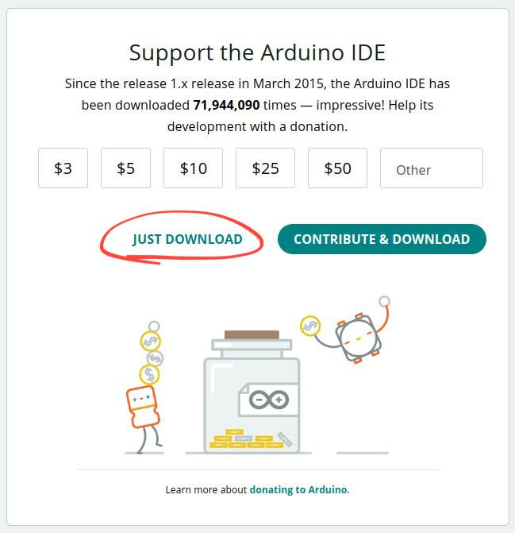
1.2. How to set the time for the pumps

- The process to change the date & time for the pumps involves 2 main stages: modify the script and upload the script to the board.

1.2.1. Modify the script

- There will be 3 files as below:

- once_per_week.ino: inside once_per_week folder, use to activate the pumps only once a week on a specific time

- twice_per_week.ino: inside twice_per_week folder, use to activate the pumps twice a week on a specific time

- set_time.ino: inside set_time folder, use to set the clock for the pumps

- You will first need to choose a file based on your need to run the pump, then you’ll need to open it with the Arduino IDE.

Activate the pumps once a week

If you are opening the file to run the pump once a week (once_per_week.ino), at line 15, 16, 17, you will see 3 variables to modify based on your preferences, including DAY, START_HH and START_MM
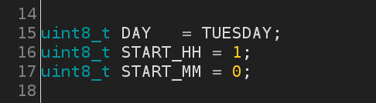

Meanwhile,
- DAY: the day you want to activate the pump, replace any day you want the pump to run after “=”, but it must be in CAPITAL and don’t forget the “;” at the end.

- START_HH: the hour that you want the pump to activate, replace it with any hour you want it to run on 24h format, also don’t forget the “;” at the end.

- START_MM: the minute that you want the pump to start running, replace it with any number from 0-59 based on your preferences, also please don’t forget the “;” at the end.

Example: If you want to run the pump on Thursday, at 4:30 PM every week, you’ll just need to adjust the variables in line 15, 16, 17 as below.

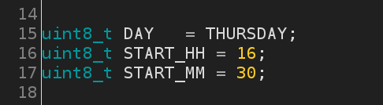

Activate the pumps twice a week

If you are opening the file to run the pump twice a week (twice_per_week.ino), at line 15, 16, 17, 18, you will see 4 variables to modify based on your preferences, including DAY_1, DAY_2, START_HH and START_MM
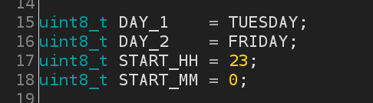

Meanwhile,

- DAY_1 and DAY_2: the 2 days you want to activate the pump, replace any days you want the pump to run after “=”, they must be in CAPITAL and don’t forget the “;” at the end.

- START_HH: the hour that you want the pump to activate, replace it with any hour you want it to run on 24h format, also don’t forget the “;” at the end.
- START_MM: the minute that you want the pump to start running, replace it with any number from 0-59 based on your preferences, also please don’t forget the “;” at the end.

Example: If you want to run the pump on Tuesday and Friday, at 7:45 PM (19:45) every week, you’ll just need to adjust the variables in line 15, 16, 17, 18 as below.

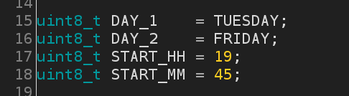

1.2.2. Uploading script to the pump

Step 1: You’ll need a USB to Mini USB cable to connect the pump with your computer, the mini USB cable will be looking like this

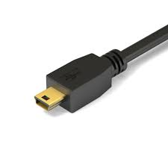

Step 2: After that, you will need to plug the mini USB cable to the board as below
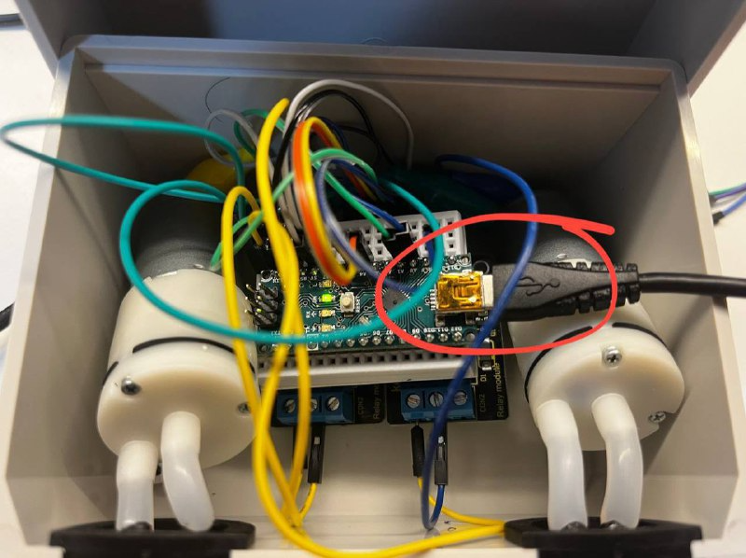
Note: when plugged in, the board will have 3 lights light up at the same time, then green light will remain on
Step 3: On the Arduino IDE application on your computer, you’ll need to go into Tools → Board → Arduino AVR Boards → select Arduino Nano (this step only need to be done once)

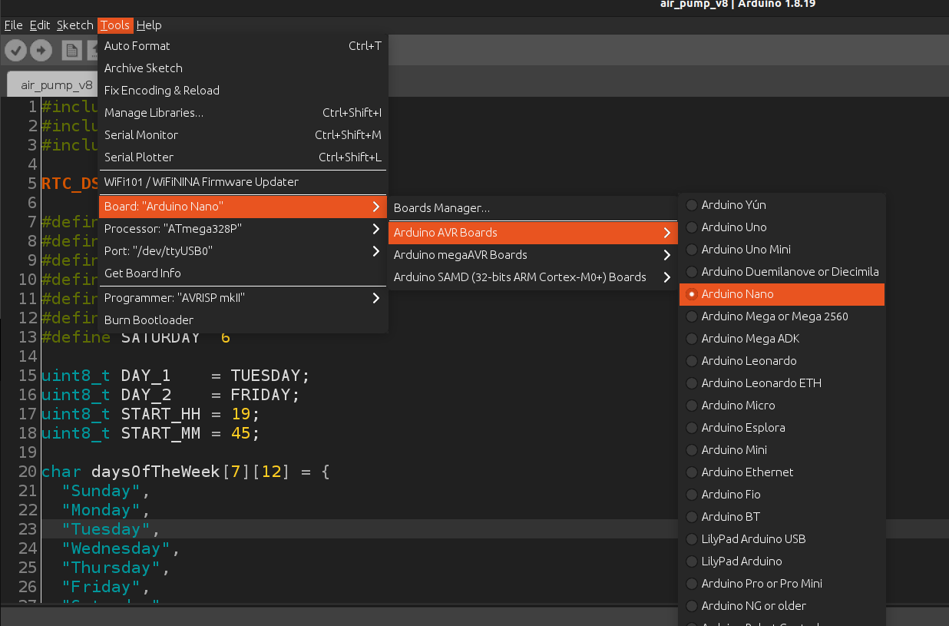
Step 4: On Arduino IDE, choose Tools → Port → Select the port that is currently being used by the board (usually USB0 port)
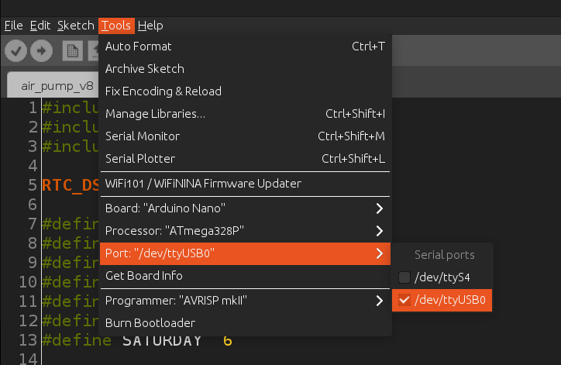

Step 5: Click on this button to upload the script

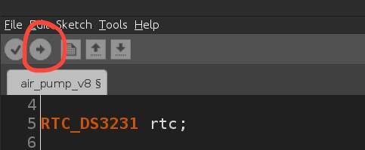

Note: If you see it’s saying “Done uploading” after a few second when you clicked the button above, that means you have successfully uploaded the script to change the time.

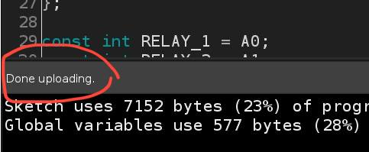
To confirm whether the pumps are running well, you’ll need to open the terminal from Arduino IDE by press Ctrl + Shift + M or ⌘+ Shift + M (on Mac), if you’re seeing a window pop up displaying the real time and there is a 9-10s gap between each output, and the time it is set to run that means the clock is working alright and the pump is ready to go
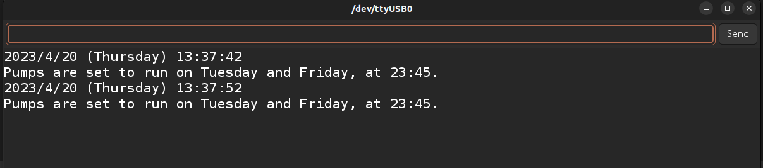
If the above combinations does not open the terminal window, you can open it from Tools → Serial Monitor

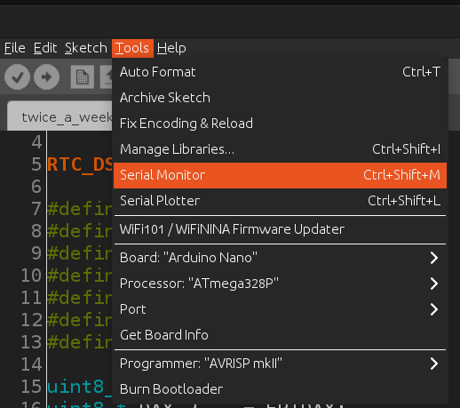
Note: If you are seeing the time outputing from the window does not match with the time in reality, it is most likely that the clock need to be reset, in this case (which is very rare), you will just need to run the file “set_time.ino”, open & upload it the same was as we upload the script above, then you’ll have to re-upload the script file again, after that, you can open the terminal to check on the clock status again.

2. Batteries replacement & notice

- The batteries that are being used in the pumps are 4x AA batteries, you can replace them by taking them out of the battery holder and place new batteries back again.

- You don’t need to load the script again or plug the pump to your computer, the pumps will be power down while you’re replacing the batteries but the clock is still working and it can get back to work as normal as before once you have finished replacing the new batteries

- Note: In case the battery holder fell out of the pump, here is how you can wired it back in again

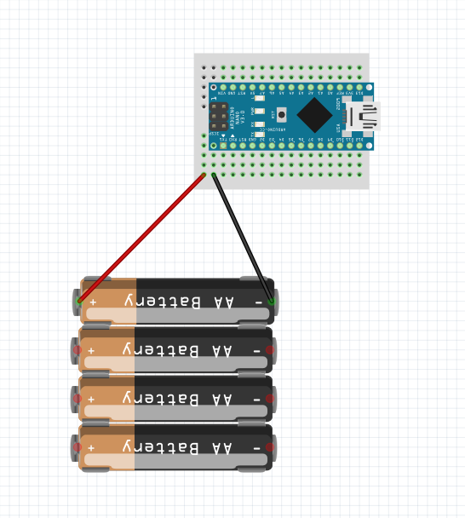
Note: Red wire is wired on the very left pin and black wire is wire to the right pin next to black wire.

